101

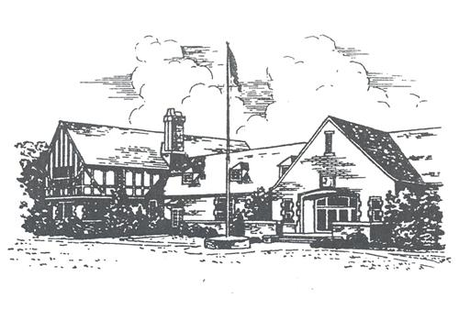

3020 Cambridge Road
Mountain Brook, AL 35223
Phone: (205) 871-8191
Fax: (205) 877-8330
www.mtnbrook.k12.al.us/MBE
www.mbelancerpto.com

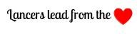

Principal
Ashley E. McCombs mccombsa@mtnbrook.k12.al.us

Assistant Principal
Brannon T. Aaron aaronb@mtnbrook.k12.al.us

Secretary
Ginger Hollingsworth
hollingsworthg@mtnbrook.k12.al.us

Bookkeeper
Adam Craiger
craigerj@mtnbrook.k12.al.us

Mascot
Lancer

Colors
Red & White

Mountain Brook Elementary History

Mountain Brook Elementary School first opened its doors to students in 1929. As the oldest existing public school in the Mountain Brook area, Mountain Brook Elementary enjoys a rich history of community support and educational excellence. Its distinguished tradition continues today as the Mountain Brook City School system consistently ranks among the top public school systems in the nation. Throughout its history, many of the improvements to the school and its physical plant have been made possible through the vision, commitment and support of the many loyal parents, former students, friends and neighbors who comprise the Mountain Brook Elementary School community. With an enrollment of more than 500 students in pre-kindergarten through sixth grade, MBE celebrates over 90 years of service to the community. A tradition of continuous improvement remains a historic keystone of MBE, maintaining a standard of educational excellence and community involvement that began nearly a century ago.

Welcome!

On behalf of the PTO, faculty and all of our Mountain Brook Elementary (MBE) families, we would like to welcome you to our wonderful school. We know that starting a new school can be a bit overwhelming, not only for the students but also for the parents. We hope this booklet will give you the answers you are seeking and make your transition as smooth as possible.

Daily School Hours

First Morning Bell 7:45 a.m.
Tardy Bell 7:50 a.m.
Dismissal Bell 2:50 p.m.

Arrival
Students arriving between 7:20 a.m. and 7:40 a.m. typically go to the following locations where they will be supervised and released to their classrooms beginning at 7:40 a.m. Any student arriving between 7:40 a.m. and 7:50 a.m. should report directly to their classroom.

Note: The 2020-21 school year will begin with students arriving as early as 7:20 a.m. where they will go to the locations mentioned above until 7:30 a.m. any student arriving between 7:30 a.m. and 7:50 a.m. should report directly to their classroom. All other factors remain unchanged.

-Walkers (front door entry only): Lunchroom
-Cambridge Carpool: Lunchroom
-Heathermoor Carpool: Community Room Hall

Students entering school after 7:50 a.m. are considered tardy and an adult will need to sign them in at the front office. Once the tardy bell rings, the personnel supervising carpool enter the building and security doors lock behind them. Please be aware that students will only be able to re-enter the building through the front doors after 7:50 a.m. and should be accompanied by the adult dropping them off.
Dismissal
The dismissal bell rings at 2:50 p.m. at which time there are three routes students can take based on their carpool location:

-Walkers: Exit Front Doors
-Cambridge Carpool: Pick-up Under Porte-Cochere
-Heathermoor Carpool: Pick-up Through the Tennis Court Loop

Note: The 2020-21 school year will begin with students dismissing by staggered bells with 5-minute increments to minimize crowding. Pick-ups will run as usual beginning at 2:50 p.m.

Table of Contents

- Important School Happenings

- Lancer PTO Information

- Carpool Procedures

- Extended Day Program

- After School Activities

- School Lunch Information

- School Procedures

- Leadership at MBE

- In The Know

- MBS App Information

- Miscellaneous Information

I. Important School Happenings

Informational Sessions

Newcomer Party 1st-6th grades
(Note: This does not include kindergarten.) Before school begins, all new MBE students entering 1st-6th grades are invited to a meet and greet. Students and parents will have the opportunity to take a brief tour of the school and to meet the administration.

Kindergarten Orientation
Orientation is normally held in April for parents and children. This is a time for the children to take a tour of the school led by the kindergarten teachers while parents participate in a Q&A with PTO and administration.

Meet the Teacher
Before school begins, class lists are posted at the school and emailed to parents. Time slots for you to meet your child’s teacher are provided to you based on your last name and scheduled for the day before school starts. This is simply a time meant for a classroom visit and for families to meet the teachers.

Open House
This is held one evening after the school year begins. For the 2020-21 year, we will have a virtual meeting. Teachers will talk to parents about expectations for the year like procedures, projects and field trips.

Fall Conferences
This is a time for communication about student progress. Conferences in grades 3rd-6th are student-led and are held over three days in October. You will have the opportunity to sign-up for a 20 min time slot. School dismisses at noon on these days.

Spring Conferences
This is a chance to meet one-on-one with your child’s teacher(s) to discuss academic, social and behavioral progress. Spring conferences are optional and are held over two days. You will have the opportunity to sign-up for a 20-minute time slot. School dismisses at noon on these days.

Communication
MBE’s webpage is a place where upcoming events, links to PTO information and resources for parents can be found.

Lancer Living is a monthly newsletter sent by Mrs. McCombs to update parents on the upcoming month’s events and happenings at MBE.

Grade Level Teams prepare weekly newsletters containing information about academic assignments, event reminders and other relevant need-to-know information pertinent to the school and their grade level.

Google Classroom is the digital learning platform for grades PreK-4th used for assignments and ongoing announcements.

Canvas is the digital learning platform for grades 5th-6th used for assignments and announcements.

Seesaw is a digital portfolio available for every PreK-6th grade student. This is an interactive tool where students and/or teachers can post examples of student for interactive feedback from parents, teachers, or peers. Parents can set-up notifications that lets them know when their student has posted something to the platform.

Email can be used to notify the teacher of any changes to your child’s school day and/or additional information you need to share

Learning Opportunities

School Spelling Bee
Students in grades 4th-6th participate in the school-wide Spelling Bee. The winner of the school bee goes on to compete at the district level in January.

National Geography Bee
Students in grades 4th-6th participate in the school-wide Geography Bee. The winner of the school bee goes on to compete at the state level in the spring.

Expressions Art Contest
This district event is open to all students. Entry categories are photography, literature, visual art, music composition, videography and film. This is a great way for your child to showcase their unique talents! School winners advance to compete at the district level.
Renaissance Festival
New to MBE this year, formally known as the Writers’ Festival. We are expanding to not only include authors/illustrators, but possibly scientists, mathematicians and other cultural learning opportunities. This is an exciting event that encourages student creativity and taps into the knowledge of experts across a variety of fields!

E-Day
There will be two E-Days each year, one in the fall and one in the spring. E-Day is a day in where students receive their classroom instruction electronically. This day will require your child to work from home digitally without physical attendance in the school building. E-Day instruction is linked to grade level standards, is real-time learning and connected to in-class learning. It should reflect a normal school day and is a valuable day of instruction. Teachers across the district use this time for professional learning.

Specials
Students participate in one ‘Special’ each day in addition to PE. Specials include: Art, Music, Library, Spanish and STEM. Counseling lessons are embedded throughout the year to support social-emotional learning and bullying prevention.

School Events

Boo Bash
The MBE community meets for a fun day where students engage in carnival activities and students and faculty alike can dress-up in costume. This event takes place during school hours and each grade has a specific time slot to participate with their teachers. Parents are invited to attend and help with carnival booths. This is a free event to all students due to the generosity of Lancer Sponsors!

Scholastic Book Fair
This book sale is a week-long event held in the auditorium. Each class will have the opportunity to shop during the sale. Parents and grandparents are also encouraged to attend with their child’s class. The proceeds from this event support the MBE library.

Lancers on the Lawn
This is a casual afternoon of fun with MBE families and staff. This community event is usually held on a weekend afternoon in the spring. There is food, a band and much more.

Field Day
This event is held the last week of school and is a fun day for students and staff. Students compete in relay races with the other classes in their grade.

Camp Alpine
During the Spring, our 5th graders travel to Camp Alpine in Mentone, AL. Our week at Alpine is an amazing experience led by MBE’s 5th grade teachers. This experience enables learning to take place outside of the school's walls and allows for growth academically, socially, emotionally and physically.

Teacher Appreciation
Throughout the year each class provides snacks for the teachers and staff once a week. Each class will be assigned a week. Teacher Appreciation Week is in May and is a time to show our MBE teachers/staff how much they mean to us. There is a special luncheon planned by PTO during the week, as well as the first week of school and before the holiday break.

Programs/Performances

Alabama History Program
Each year the 4th graders showcase famous Alabama residents through singing, speeches and costumes.

Veteran’s Day Program
This program is performed by the 5th grade students. It is a special time that honors parents, grandparents, aunts, uncles and other family members who have served or are currently serving our country. MBE families and Veterans are invited to attend this program with their child.

Holiday Program
All PreK-3rd grade students participate in the holiday program. Performances are usually held in the morning shortly after the school day begins. Children perform for 3 mornings in a row, and each grade will be assigned a day for parents and guests to attend.

Leadership/Grandfriends Day
This is an event in which students invite a special friend to come and visit their classroom and share all of the exciting things going on at MBE. The friend can be a grandparent, neighbor, community member or someone who is special to the child.

6th Grade Lancer Walk
This is when the sixth graders take one last walk through the school. All classes stand in the hallway to cheer on the outgoing students.

6th Grade Honors Day
This is an assembly where sixth graders are celebrated and receive honors. Sixth grade parents are encouraged to attend.

- Lancer PTO Information

We would love for you to get involved. You can do this in a variety of ways. Volunteering your time is a wonderful way to give back to the school! You can contact the current PTO President, Hill Weathers, at hillweathers@hotmail.com, to sign up and get connected to the amazing things taking place at school. MBE could not be what it is today without the financial support provided by parents and family members, as well. Please consider becoming a Lancer Sponsor. We are able to give the money you donate directly back to the school. These funds support school improvements, teacher stipends, technology enhancements and many special events and projects throughout the school.

To become a Lancer Sponsor or sign up to volunteer please go to our website: mbelancerpto.com.

For reminders and happenings around the school, follow the MBE PTO at:
Facebook: Mountain Brook Elementary Lancer PTO
Instagram: mbe_pto

Partnerships in our community

ALL IN Mountain Brook
ALL IN provides information and support to parents in three key areas: alcohol and substance awareness, mental health and wellness, and safety and preventable accidents. Programs are held for parents to attend to learn from speakers, and helpful resources are posted on their website at allinmountainbrookorg.

Mountain Brook City Schools Foundation
The foundation partners with all Mtn. Brook schools to assist in filling the gap between government funding and helping fund technological, professional development and library enhancements.

- Carpool Procedures

There are two carpool routes at MBE, Cambridge and Heathermoor (see larger scale carpool map). You choose the carpool route that is most convenient for your family based on where you live.

Cambridge and Heathermoor become one-way streets each weekday at the following times:
7:15 a.m. - 8:15 a.m.
2:15 p.m. - 3:30 p.m.

To receive your carpool number, please fill out a carpool form that can be found online at mbelancerpto.com. Due to possible inclement weather, all students need a carpool number, even if they are walkers. Please display the carpool number in your window so staff on duty can easily prepare your child to dismiss.

Any changes in carpool need to be made to your child’s teacher with a copy to the office secretary before 2:00 p.m. that day in order to guarantee the message is received.

Please begin lining up no earlier than 2:30 to avoid traffic build-up on community roads. Walkers are considered anyone who lives within walking distance of the school. All other families should use the carpool routes vs parking on adjacent streets for student pick-up to optimize safety. Safety is our top priority and with the many walkers at MBE, we want to be able to account for every child in our care. Please also keep all contact information and permissions for pick-ups current.
Carpool Map
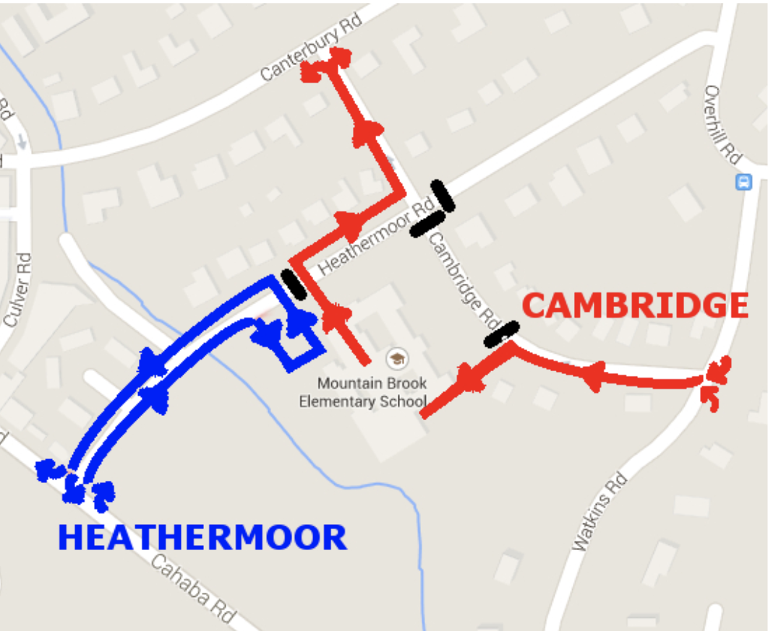

- Extended Day Program (EDP)

MBE offers an after-school program for students attending the school. This program is available until 6:00 p.m. unless otherwise informed. More information can be found on the school’s webpage.

- After School Activities
All of these go through the district Community Education program. You will occasionally see flyers in your child’s backpack advertising activities, such as chess, dance and karate. Call 205-877-8349 for more information.

VI. School Lunch Information

Payment for lunch accounts may be paid via check, cash or through Pay Pams. For the 2020-21 school year, we are encouraging digital payments be made to avoid multiple touch items.

You can set up a Pay Pams account via the Mountain Brook Schools website by selecting the following links: Departments/Child Nutrition/Pay Pams. Once an account is set up, you can schedule automatic payments or go online to pay manually when the balance is getting low. There is a processing fee when paying online.

You can access the school lunch menu via the MBE website and the MBS app.

Student Lunch: $3.00
Guest Lunch: $4.50
Prices for ala carte can be found here: https://drive.google.com/drive/folders/1veZPl8e0Btz9XIqEADQJl8D5otMWu-CW.
The maximum that can be charged on an account in a single day is $10.00.

Visitors are welcome to lunch throughout the year. Check with your child’s teacher before visiting so preparations can be made accordingly. All visitors will need to go to the school office and submit a drivers license for a visitors sticker prior to joining your child in the lunchroom.

Note: To begin the 2020-21 school year, we are limiting visitors and guests in the building. We are also limited outside food other than individual student lunches. We will keep families informed of all changes.

For additional information, contact the school’s lunchroom manager at MBELUNCH@mtnbrook.k12.al.us.

VII. School Procedures

- If your child is going to be absent, go to the MBE website and complete the form ‘MBE Absence Reporting’ on the right side of the page. It is also helpful to email your child’s teacher and Ginger Hollingsworth at:hollingsworthg@mtnbrook.k12.al.us.

- All doors are locked during school hours, so you must press the speaker by the far-right door at the front of the school. State your name in the speaker to be let in the lobby area. Then go to the office to sign in. You must have your drivers license in order to visit the school.

Note: To begin the 2020-21 school year, we will be limiting guests entering the building. A staff member will assist you once you arrive and press the speaker.

- Typically, if you need to check your child in late, you would go to the front office to sign in.

- Typically, if you need to check your child out early, you would go to the front office to sign out. Someone in the office would then call your child to the office.

Note: To begin the 2020-21 school year, after emailing the teacher and front office secretary with details about checking your child out, you can choose to press the speaker at the front door for assistance upon your arrival, or you can call the office secretary and a staff member will escort your child safely to the vehicle. Please have your ID ready in both scenarios.

- If your child needs to take medication at school (prescription or over-the-counter), make sure you have filled out the necessary forms before leaving the medication with Trissy Condra, the school nurse. All medication must be current, labeled and in original manufacturer's container. Please NO PILLS IN A ZIPLOCK BAG!

- You can download the ‘Provider Parent Authorization’ form from the MBE webpage by selecting the following links: Resources/For Parents/Parent Homepage/Nurse-Health Services. You will need to complete and sign the ‘Provider Parent Authorization’ form for any over-the-counter medications. For all prescription medications, your physician/pediatrician will need to complete and sign the form before medication can be administered.

VIII. Leadership at MBE

Leader in Me (LIM) gives MBE a clear goal and purpose for all students, faculty and staff. The process began at MBE in 2012 with 7 Habits of Highly Effective People training for all faculty and staff. Students also began learning the 7 Habits throughout the school year in a variety of ways, such as in Morning Meetings and Leadership Celebrations.

Since that time, we have generated systems to sustain our leadership efforts, such as the Lancer League, Guilds and SeeSaw leadership portfolios. The addition of Common Sense Media and Second Step curriculums have enhanced our approach by adding an intentional focus on digital citizenship and social-emotional learning.

LIM develops school community and encourages all stakeholders to share responsibility for learning. This process led to the creation of common goals, as well as an opportunity for students to select and track their personal goals. The LIM journey has resulted in a kinder, more empathetic school community. MBE embraces a comprehensive approach that develops individuals as learners who lead from the heart.

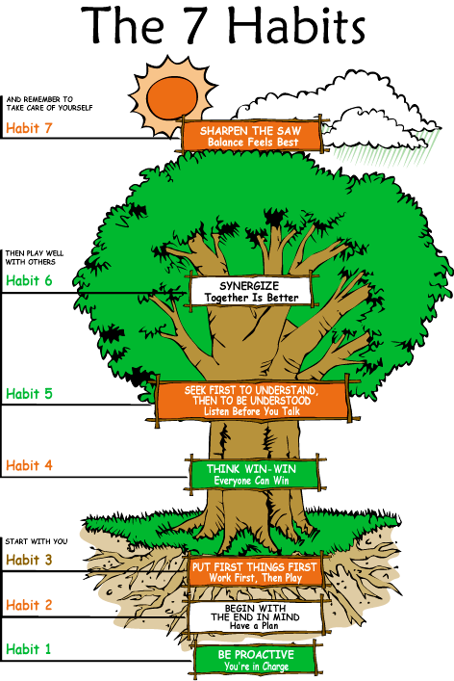

Lancer League (4th-6th Graders)

Heralds-Make weekly announcements to homerooms, pass out information/materials when necessary, celebrate birthdays.

Squires-Give school tours to newcomers/
visitors, help at assemblies, introduce speakers at special events.

Knights-Student “voice” for the school. Foster the growth of the 7 Habits by selecting books for the entire school to read.

Scribes-Hands-on, creative group. Students decorate and keep up bulletin boards in hallways with news, announcements, encouragement, etc. Make signs and flyers when needed for events.

Parchment-Publish the school newspaper. (6th grade only)

Legacy-Work to design and teach lessons to PreK-5th grade students that promote building positive friendships and recognizing individual worth. (6th grade only)

Additional Leadership Opportunities

Safety Patrol
A team of 5th graders who assist students in/out of cars during carpool.

Band (6th grade only)
Students are able to learn how to play instruments and be part of a special group. They play for students and the community during the winter season and have the chance to take a field trip together in the spring. They meet daily before school to avoid overlap of other opportunities.

Flag Raising Team (6th grade only)
The American flag is raised and lowered daily by this team. They learn the techniques of proper flag folding and respect of the flag.

Robotics (4th -6th grades)
This team participates in the VEX IQ Challenge where teams of students are tasked with designing and building robots with other teams in game-based engineering challenges. Practice takes place at MBE after school a couple days a week. Tournaments are held from September through March at the regional and state levels and culminate at the VEX Robotics World Champions each April. There is an application process to keep teams manageable in size between the two MBE sponsors. All information about Robotics is communicated by the MBE sponsors.

6th Grade Electives
This opportunity promotes student choice and positive peer interactions where kids can be leaders of their own learning alongside others with similar interests and talents. They will showcase their learning in a variety of ways throughout the year.
JUNA
Junior United Nations Assembly is model for 6th grade students and based on an application process through the enrichment teacher. Teams of students represent a nation of their choosing and research it to determine an issue of global importance. They then write and present a resolution explaining the problem and solution at a state competition each January.

Lights Camera Action (LCA)
This is MBE’s student broadcast team. 6th graders have a chance to produce and perform a daily broadcast in a state-of-the-art broadcasting room. They share daily happenings and inspirational messages.

Other Elective choices include:
Theater
Spanish
Art
Ukulele
Peer Helpers

STEM Rooms Science/Technology/Engineering/Math

MakerSpace Room
A space used during STEM Specials for additional Stemscopes activities, Dot & Dash Robots, Sphero coding/programming, Project Lead The Way Vex IQ Robotics, Keva Plank and block designs, etc. There are physical and digital opportunities for students to explore where tangible engineering, problem-solving scenarios with variables, inquiry-based activities involving student discovery and purposeful play can take place. Thanks to Lancer Sponsorships. The room is also equipped with handheld scanners/cube 3D printers, tabletop scanners/Makerbot 3D printers and Tinkercad for 3D design/modeling.

Virtual Reality Cart
Mobile cart that houses Virtual Reality goggles that students utilize to access famous landmarks and learn through images.

360 Interactive Room
Virtual and Augmented Reality is brought to life on the walls and floors of this space. Students can interact with moving objects and be immersed in virtual field trips.

IX. In The Know
What your kids will be talking about!

Blue Ribbon School
The National Blue Ribbon Schools program recognizes schools based on their overall academic performance or progress made in closing achievement gaps among various student population subgroups. MBE was identified as an Exemplary High Performing School in 2018, recognizing that MBE is among Alabama’s highest performing schools as measured by state assessments or nationally normed tests.
Lighthouse School Milestone
This milestone is awarded to schools who have shown growth in 9 major areas in relation to the implementation of Leader in Me. MBE was awarded the Lighthouse School Milestone in 2016 with re-certification in 2018 because of the school’s commitment to meeting the criteria of excellence outlined by the Franklin Covey organization.

State School of Character
According to Character.org, the "Schools of Character program offers a path to school improvement by providing a proven framework, professional feedback and models of excellence." MBE was selected as a 2018 Alabama State School of Character based on reaching this standard of excellence for addressing character in education. An additional recognition was awarded in the spring of 2020 for a ‘Promising Practice’ that recognized the Lancer League’s contributions to our school community.
Morning Meetings
Classroom communities meet at the start of every day to learn more about leadership principles and building relationships.
-Students participate in greetings that provide a structure for social skill development and character education.
-Morning Meetings embed books, songs, games, videos and goal setting. This is a way for MBE teachers and students to learn about and apply the 7 Habits in authentic situations and to build a classroom community that values one another’s differences.

Celebrations
School-wide celebrations are held each semester to recognize student accomplishments and growth.

Guilds
Guilds meet several times a year as an opportunity to promote school-wide community. These interest groups enrich students’ lives in a unique way that enables them to connect to others throughout the school who have similar passions. Students self-select which Guild to join. Guilds are designed around high interest topics and have included community partners as facilitators. Guild topics have included: Lego builds, cooking, animal lovers, football, STEM, along with many others.

Service Projects
Each grade level is assigned one month of the school year where students and teachers select a specific service project to pursue. Service projects have included: coat drives, book drives, letters to Veterans, etc. There are also opportunities for families to participate. We began partnering with students from Hayes Intermediate School in 2019 and hope to continue that partnership.

X. MBS APP INFORMATION
Helpful apps to download:

MBS Schools App (includes the following):
- Canvas for 5th and 6th grades
- Lunch menu
- MBS Classlink (houses all apps in one location)

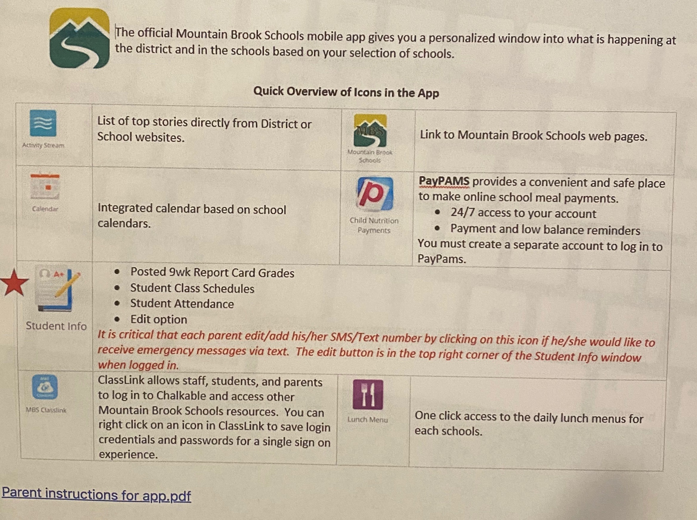

Membership Toolkit
This is our online student directory. It provides names, addresses and class lists. It is also how you can sign up to participate in PTO such as volunteering, donating to Lancer Sponsors and purchasing Sportswear.

XI. Miscellaneous

Individual and Class Pictures
Individual and class pictures are taken during the year on separate dates. Pictures are available for purchase and information will be sent home with your child with more details.

Green/Environmental
New to MBE in 2020-21 with the help from parents who focus primarily on minimizing waste production at school-wide events, as well as promoting recycling at events and daily school activities. Parents work alongside students focusing on recycling education and the execution of reducing our carbon footprint at MBE. We also have a student-driven composting bin located on-site.

MBE Yearbooks
MBE yearbooks come out during the month of May and are available for purchase during registrations. Please participate and help the PTO by sending in your pictures. Emails are sent throughout the year on how to submit these photos.

Vision Screening
Vision Screenings at school provided by an ophthalmologist. Permission slips are sent home with children and must be signed for children to participate in the screening.

Lost and Found
Items found around the school such as coats, jackets and water bottles are placed here. Please remind your child to look for lost items on a regular basis. Lost and found is located in front of the lunchroom doors. Items not claimed at the end of the school year are donated.

Sportswear
MBE and Spartan logo clothes are available for purchase and sold online through the PTO usually during the month of October.

We are excited to have you join our MBE family. Please reach out for any additional questions so we can make this as smooth of a transition as possible for your family.

Mountain Brook Elementary
3020 Cambridge Road
Mountain Brook, AL 35223

Phone | 205-871-8192
Fax | 205-877-8330
Website | https://www.mtnbrook.k12.al.us/mbe.

